NAME: Debatwik Santra Roll No: CSE /23/110 Exam Roll No: 11600223047
Assignment No- 6 : Upload a static website on S3 in AWS .
Solution:
Step 1: login to AWS Console
- Open the AWS console login page.
- Login using Root User Credentials.
- Open AWS Management Console.
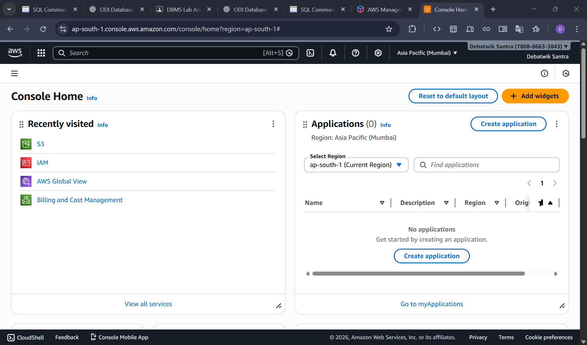
Step 2: Open Amazon S3
- In AWS Console, search S3 in the top search bar then Click Amazon S3
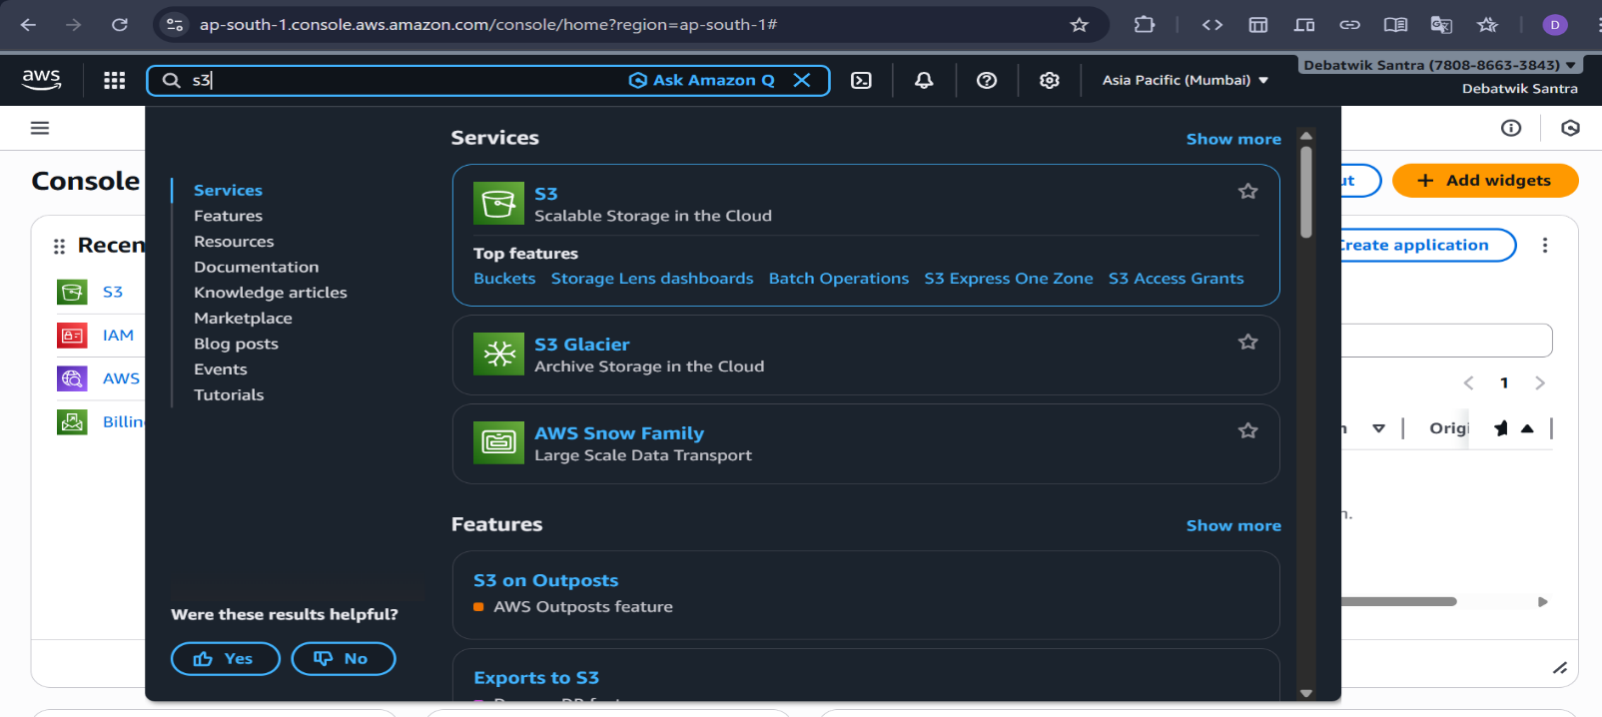

Step 3: Create a Private S3 Bucket
- Click Create bucket.
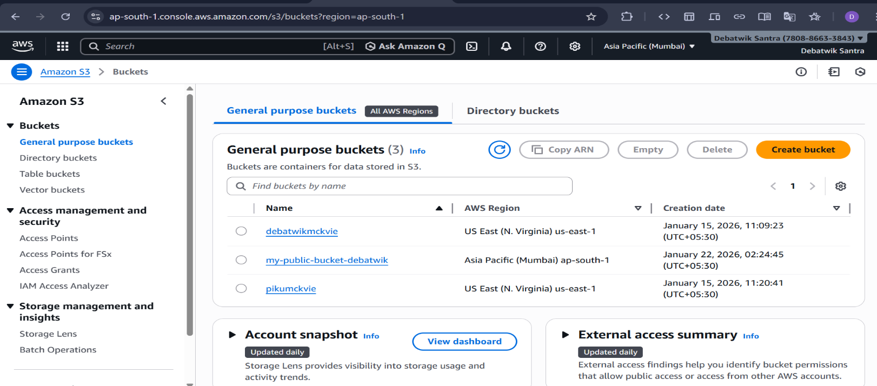
- Bucket name → must be unique
Example: my-static-website-demo
- AWS Region → select any (e.g., Asia Pacific – Mumbai )
- Under Object Ownership:
- Select ACLs enabled.
- Choose Buckets owner preferred
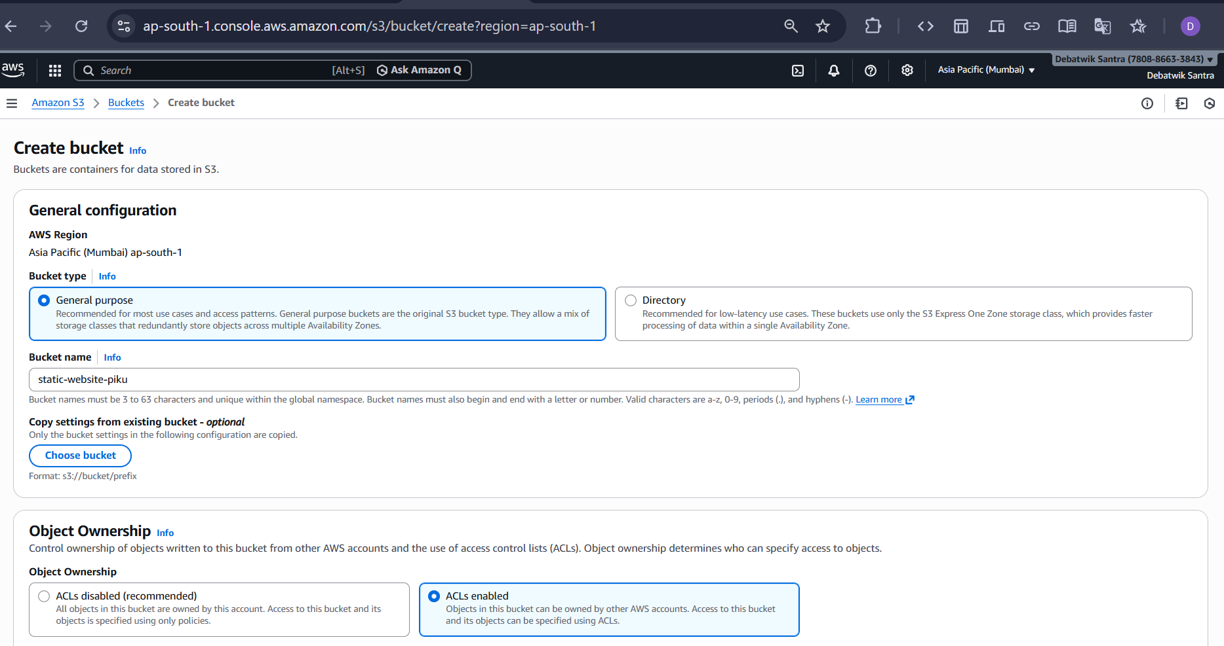
- Under Block Public Access. ( Static websites must be public.)
- Uncheck Block all public access
- Acknowledge the warning

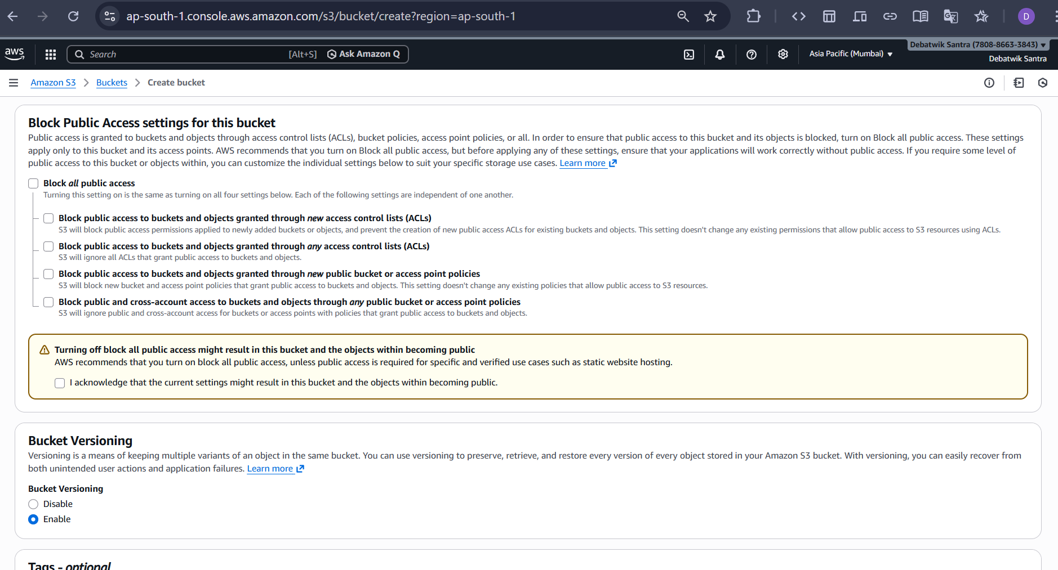
- Under Bucket Versioning: Select Enable and Also Leave the Tags as default(optional). And Click on Create bucket
- Public bucket is Ready.
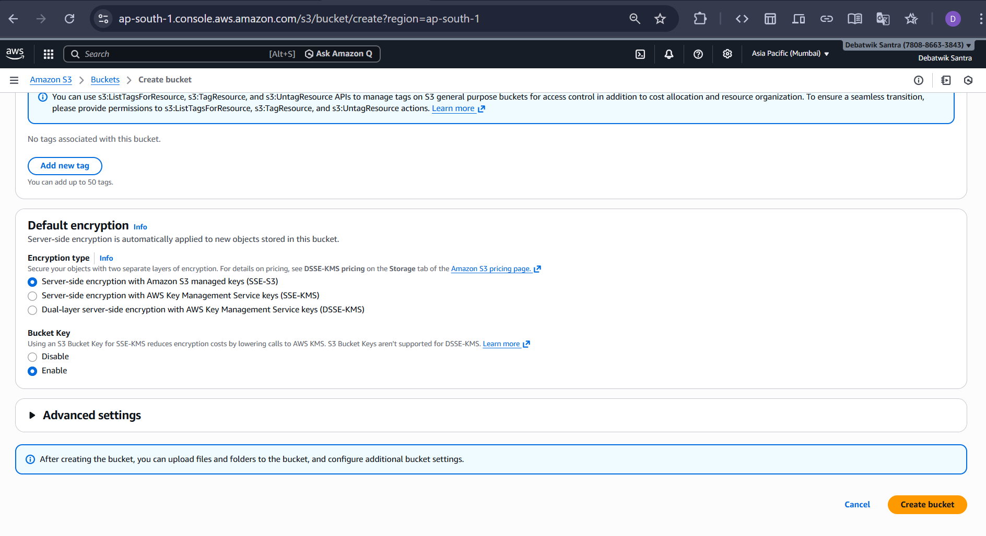
Step 4 : Upload Website Files
Prepare your files locally:
- index.html (mandatory)
Upload:
- Open your bucket

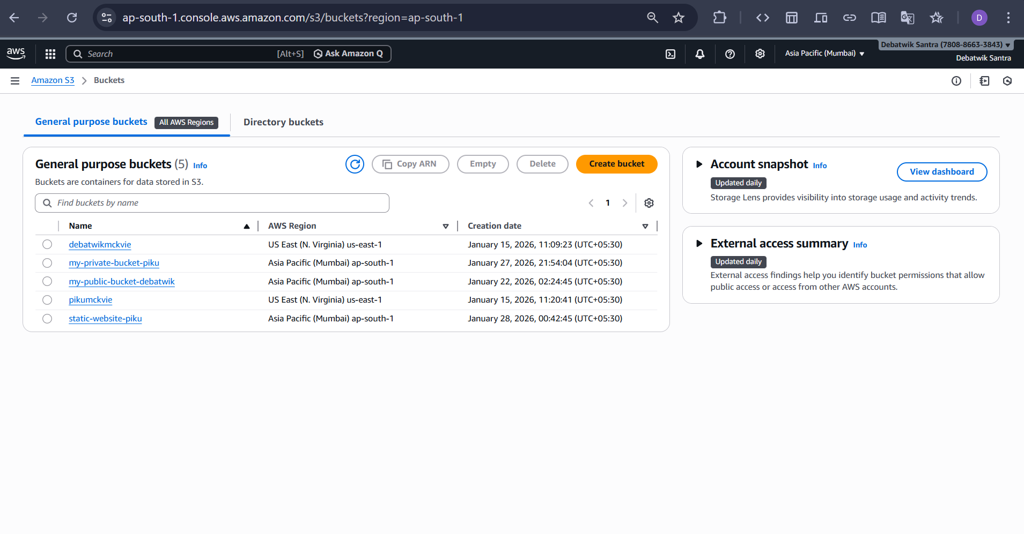
- Click on Upload
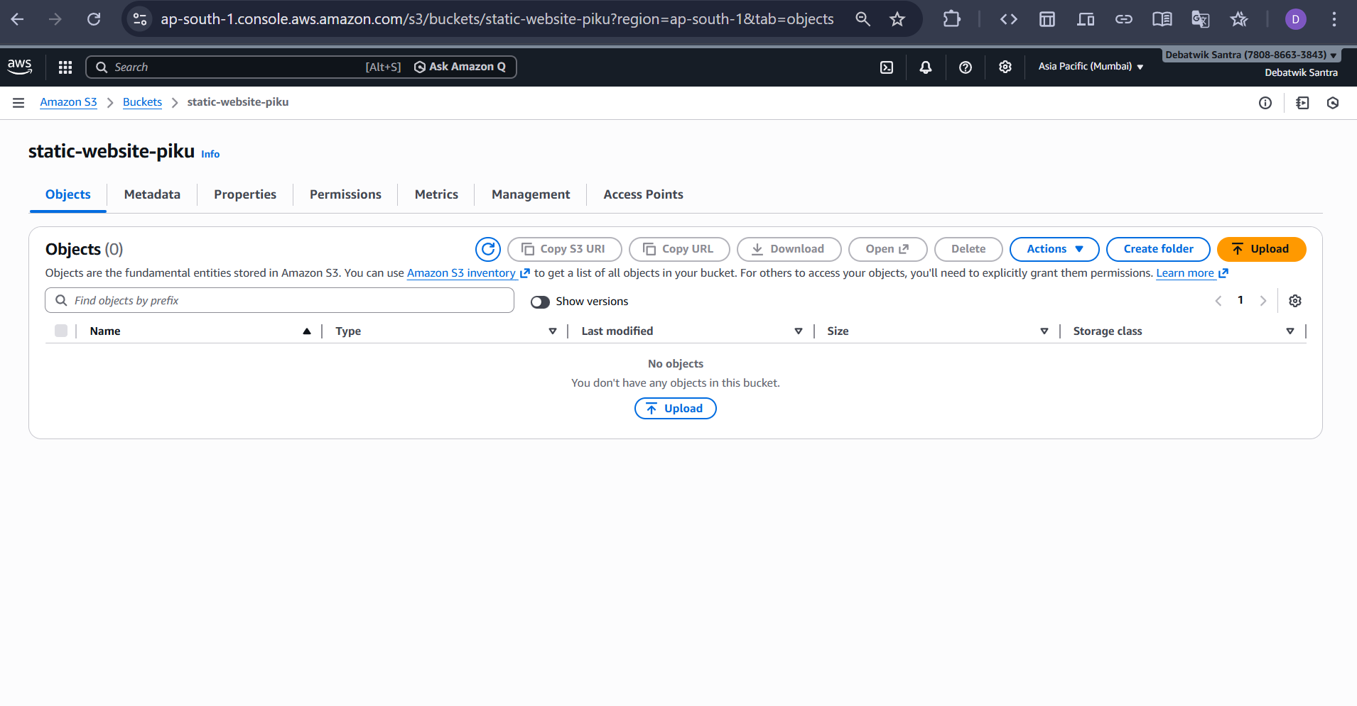
- Click Add files / Add folder
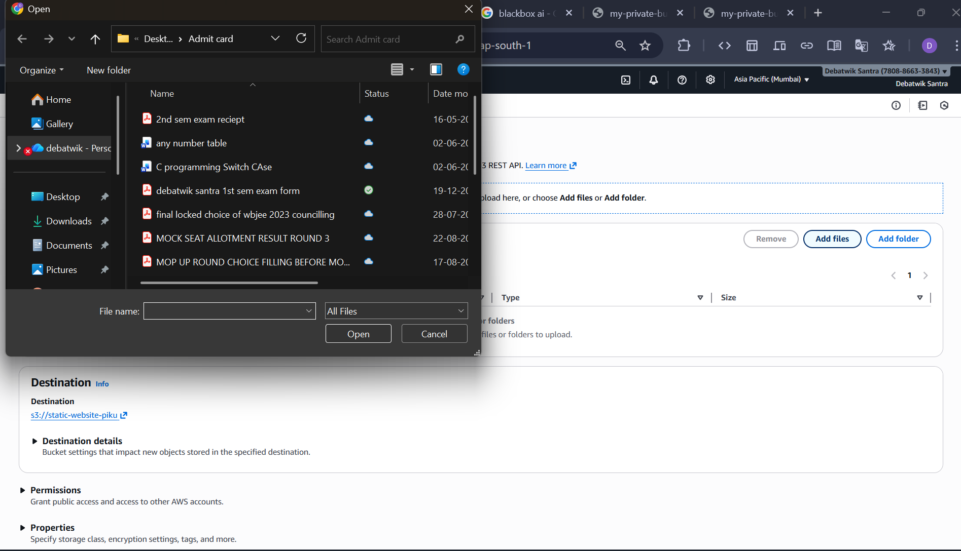
- Select all website files
- Click on Upload
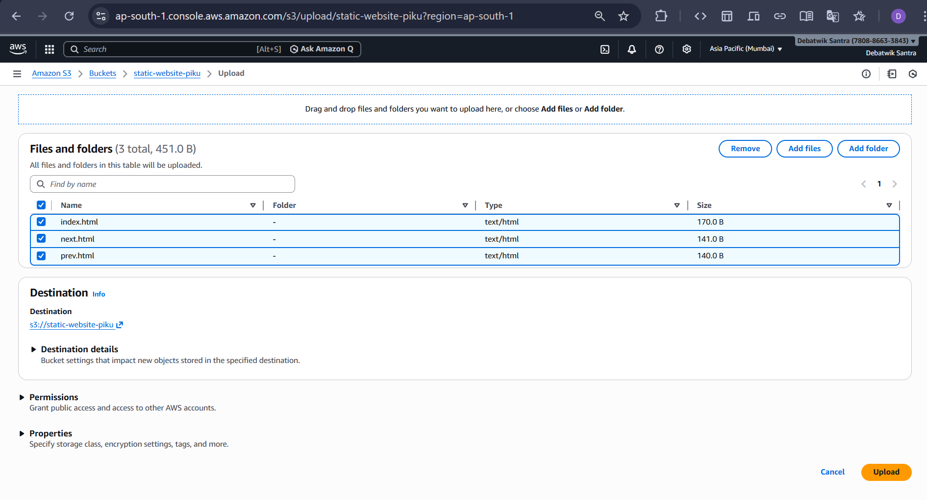
Step 5: Enable Static Website Hosting
- Open your bucket
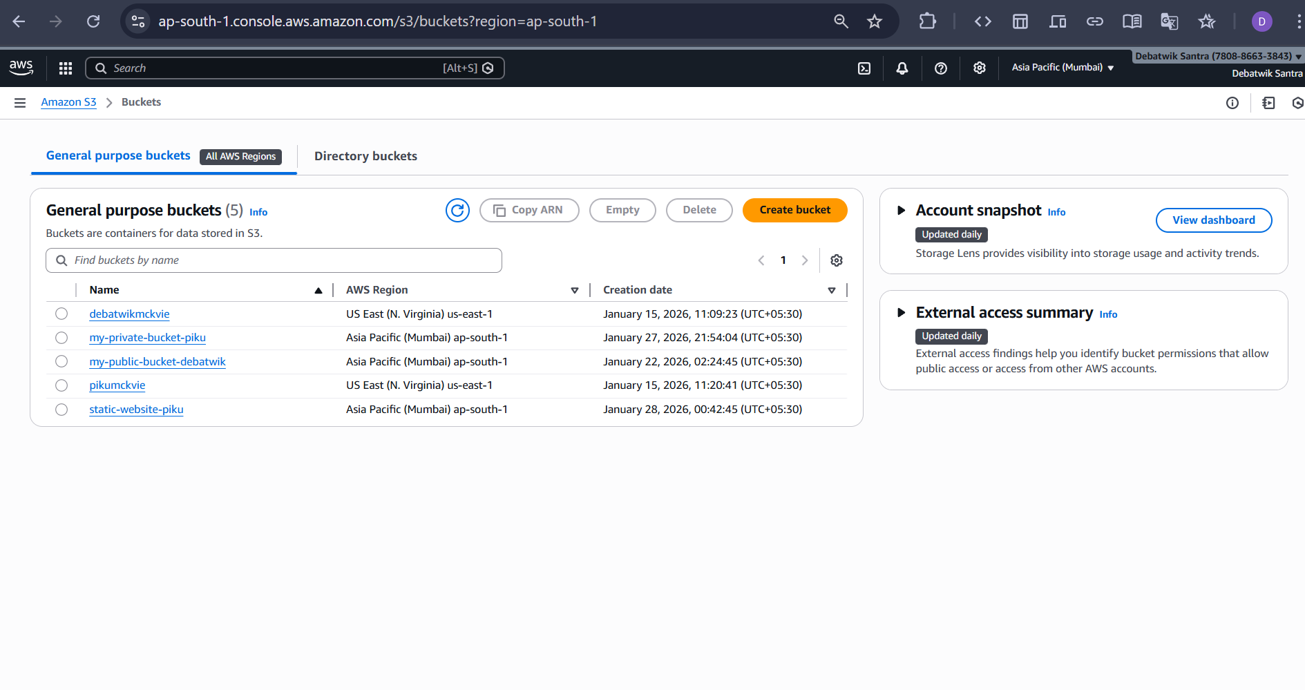
- Click on a uploaded website ( index.html )
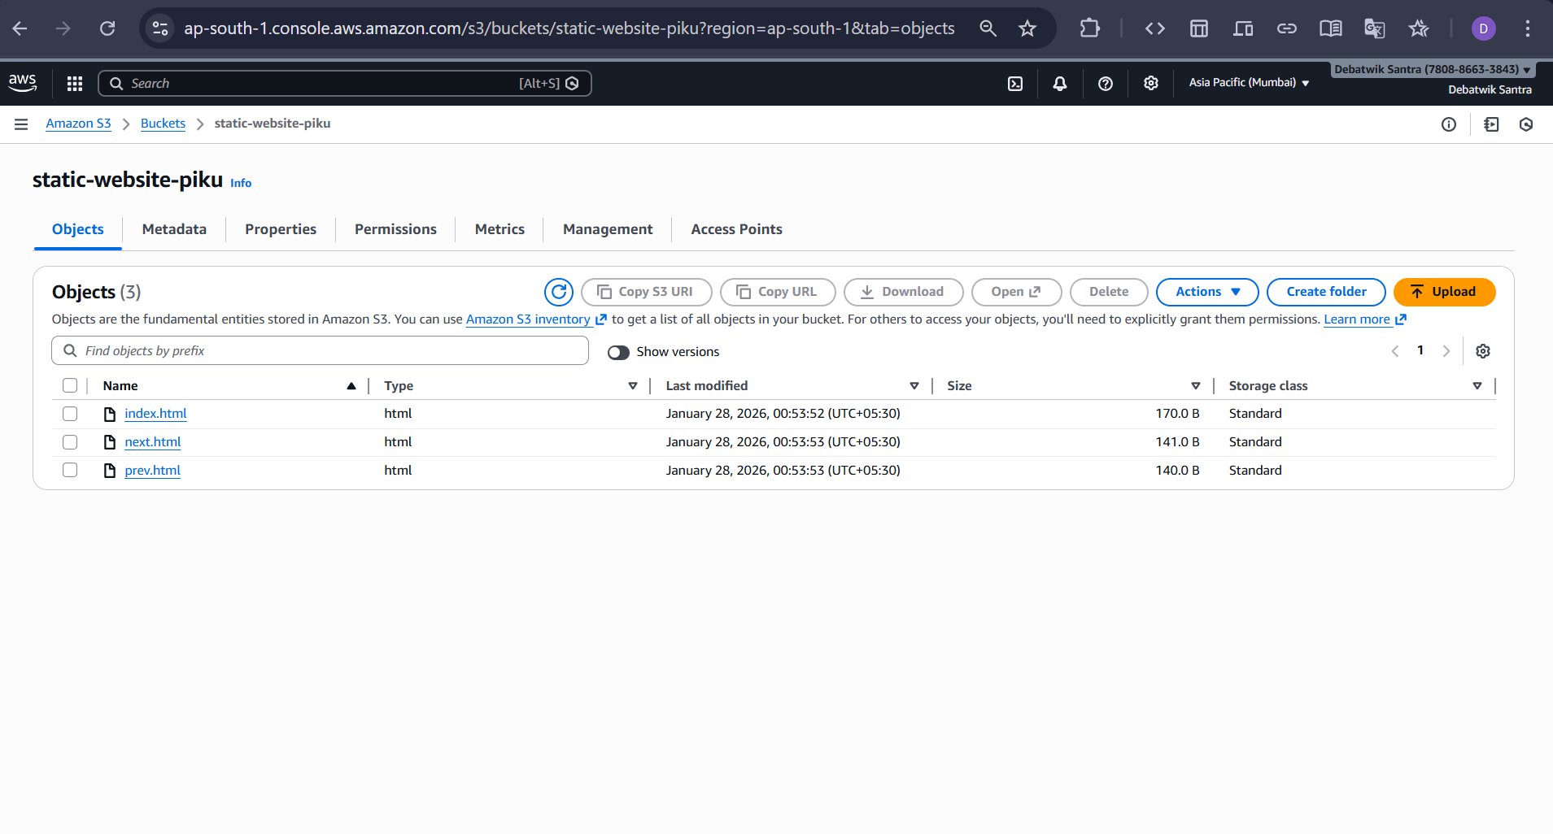
- Click on to Permission and click on Edit
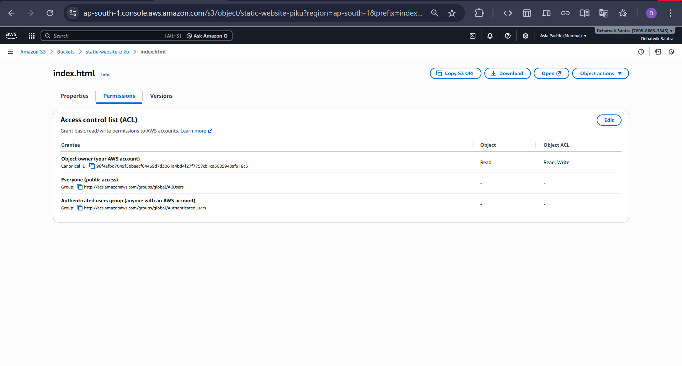
- Enable the Everyone (public access) by click on the checkboxes
- And click on the “ I understand…”
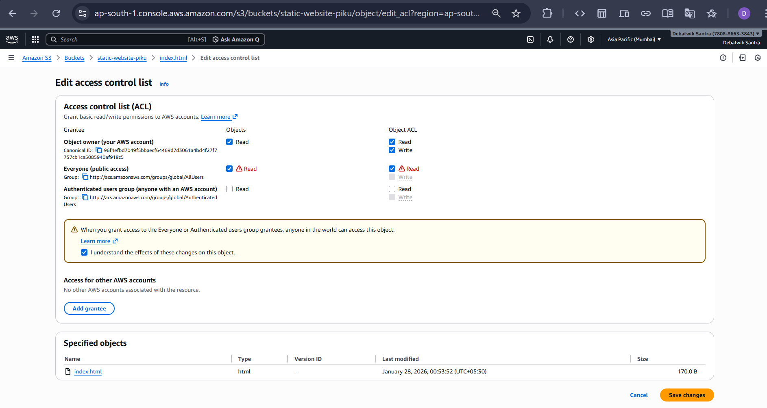
- Then Save changes.
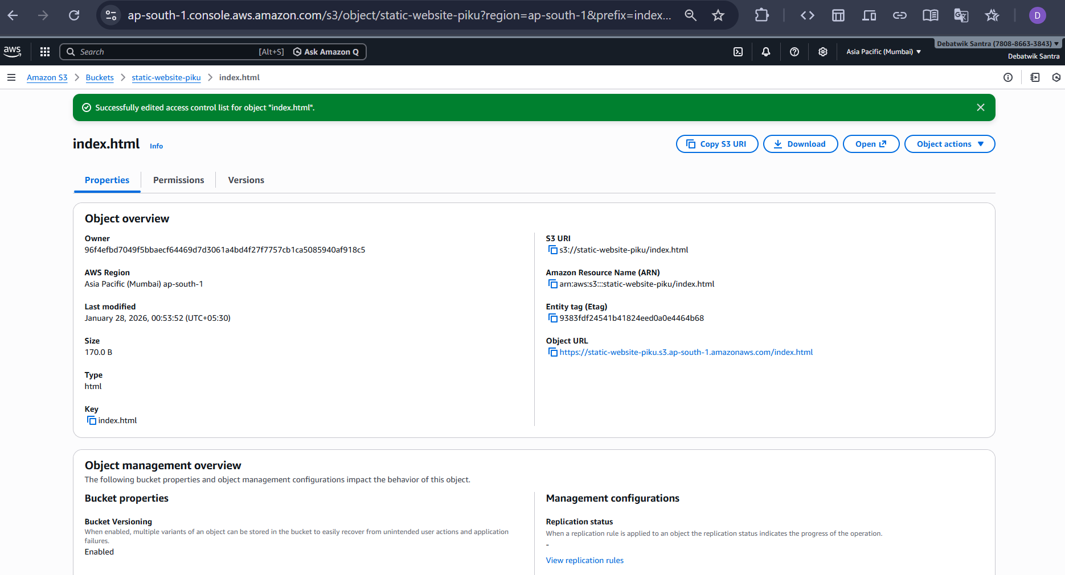
- Enable WEBSITE HOSTING successfully.
- Now like the others all uploaded websites permissions ACL( Access control list), Enable the Everyone’s (public access) by clicking on the checkboxes.
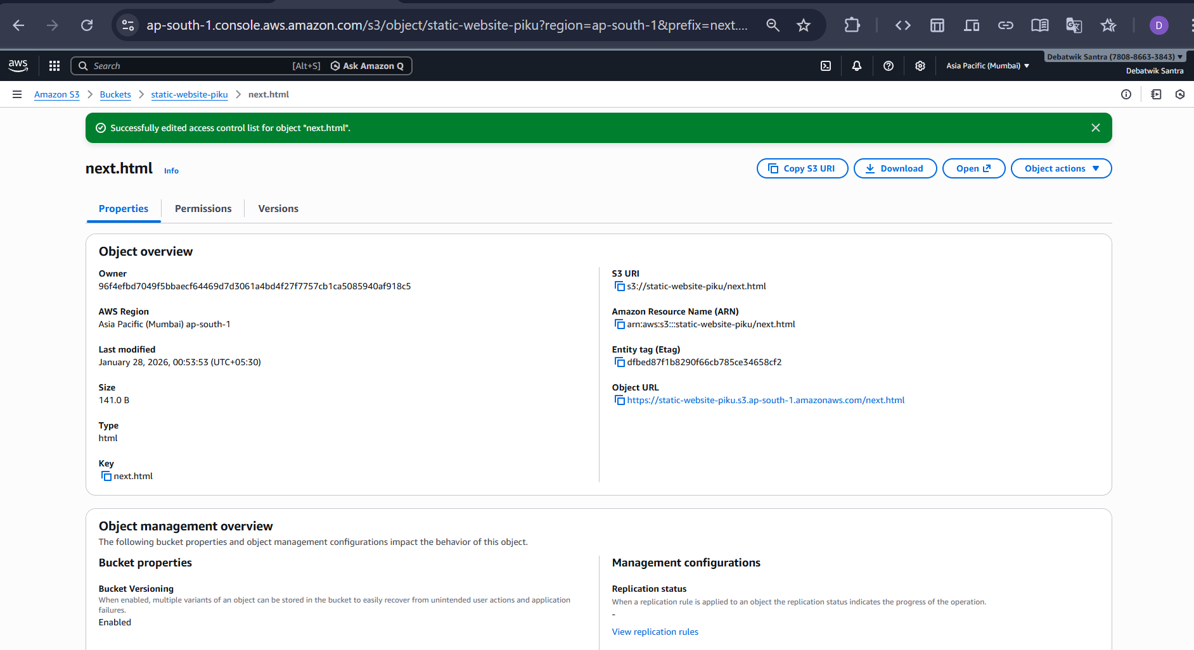
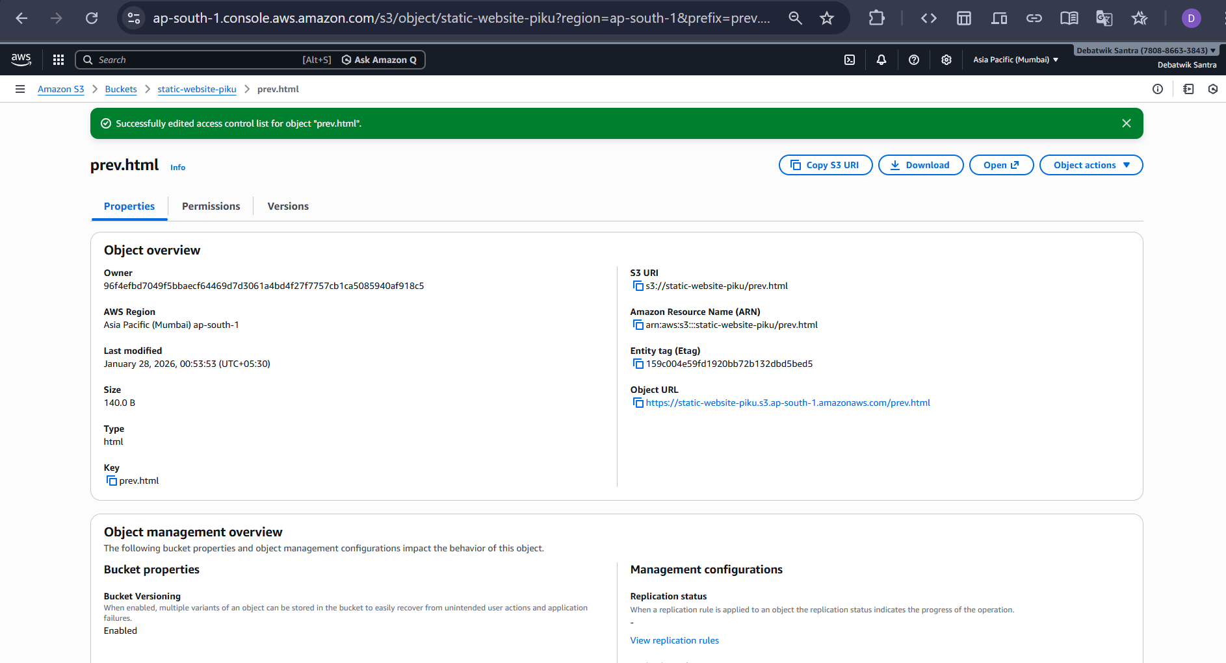
- Now the website hosting is enable we can copy the URL of any uploaded website and paste it on a new browser tab and check it then we see hosting the website is successfully.

